**Lab3 – Installing IIS in Windows Virtual Machine - Azure**

**Topology**

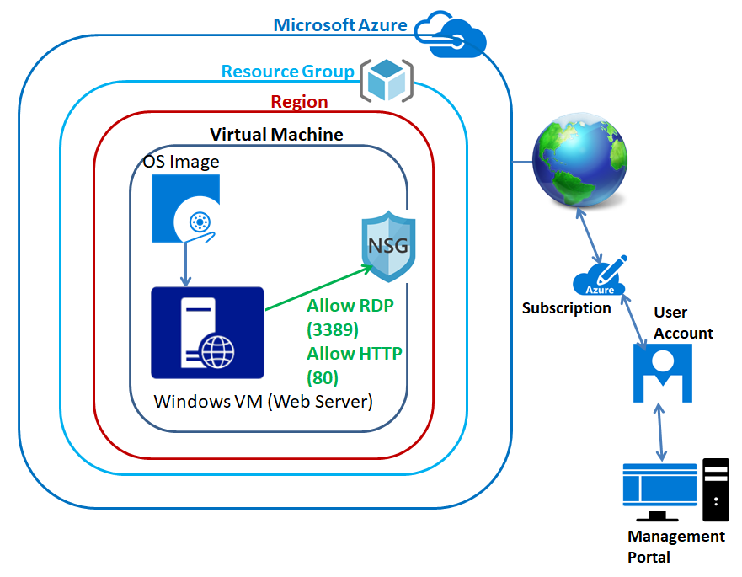

In Azure portal, click **“Resource Groups”**.

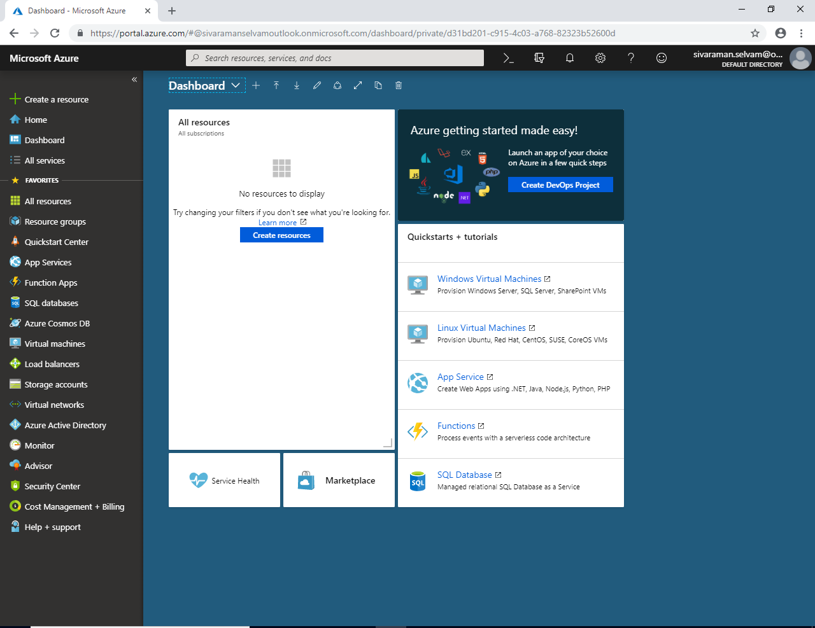

In “Resource Groups” click **“Add”.**

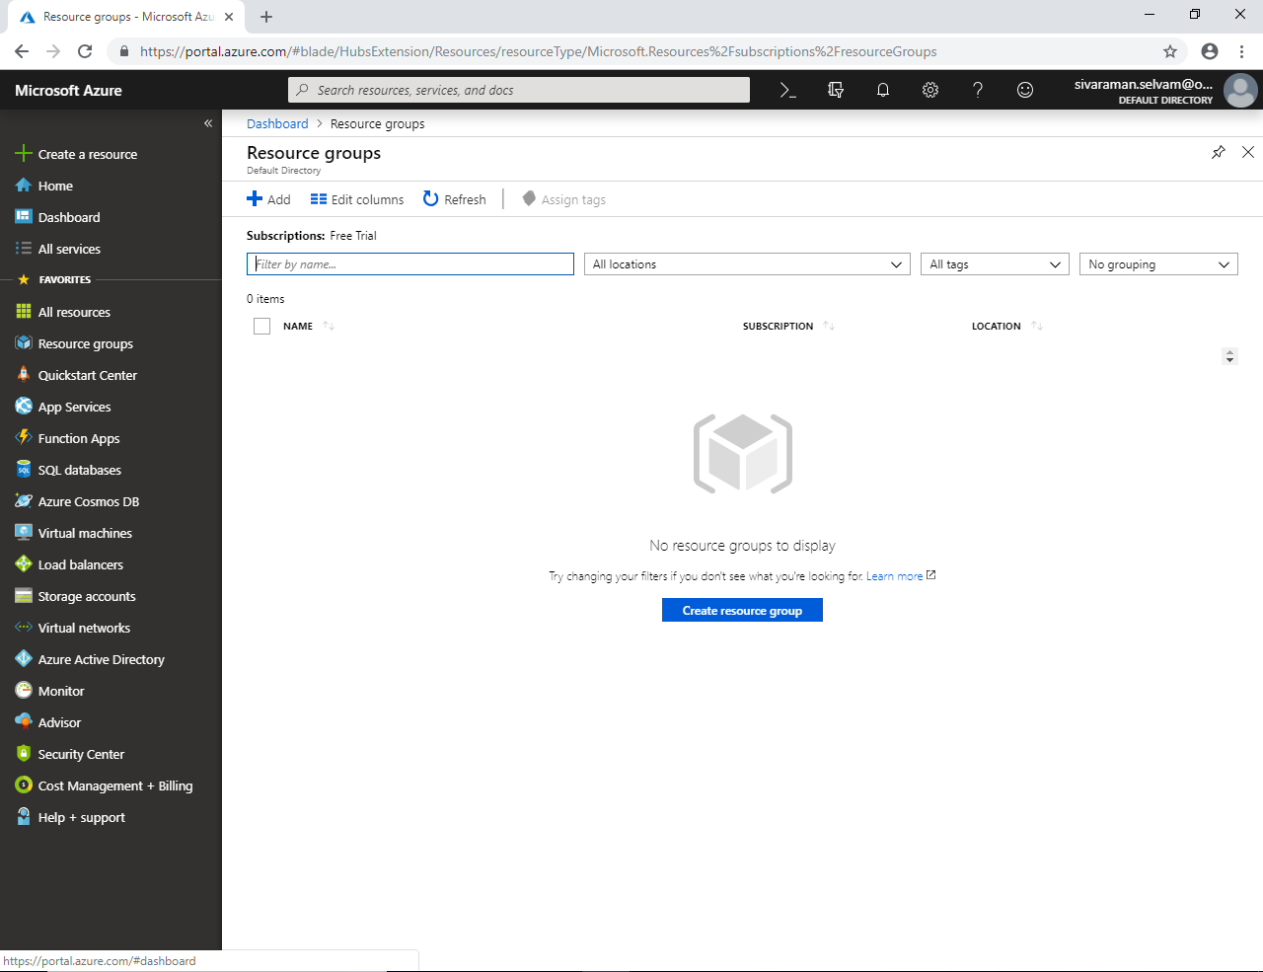

In “Resource Groups”, Type **“SansboundAzureClass”** as Resource group name.

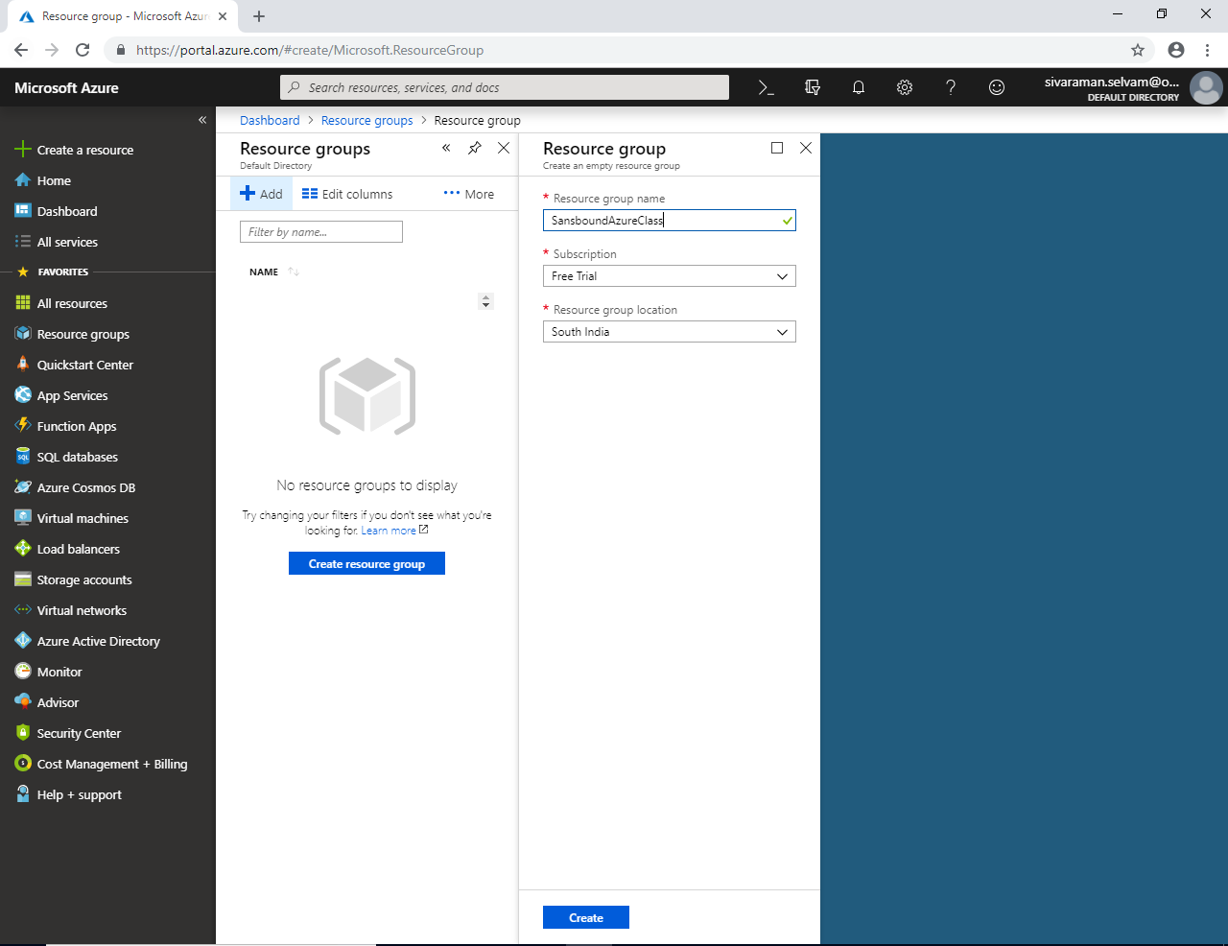

Click “Refresh” to view Resource groups.

You are able to see that created “Resource Groups” named as **“SansboundAzureClass”**.

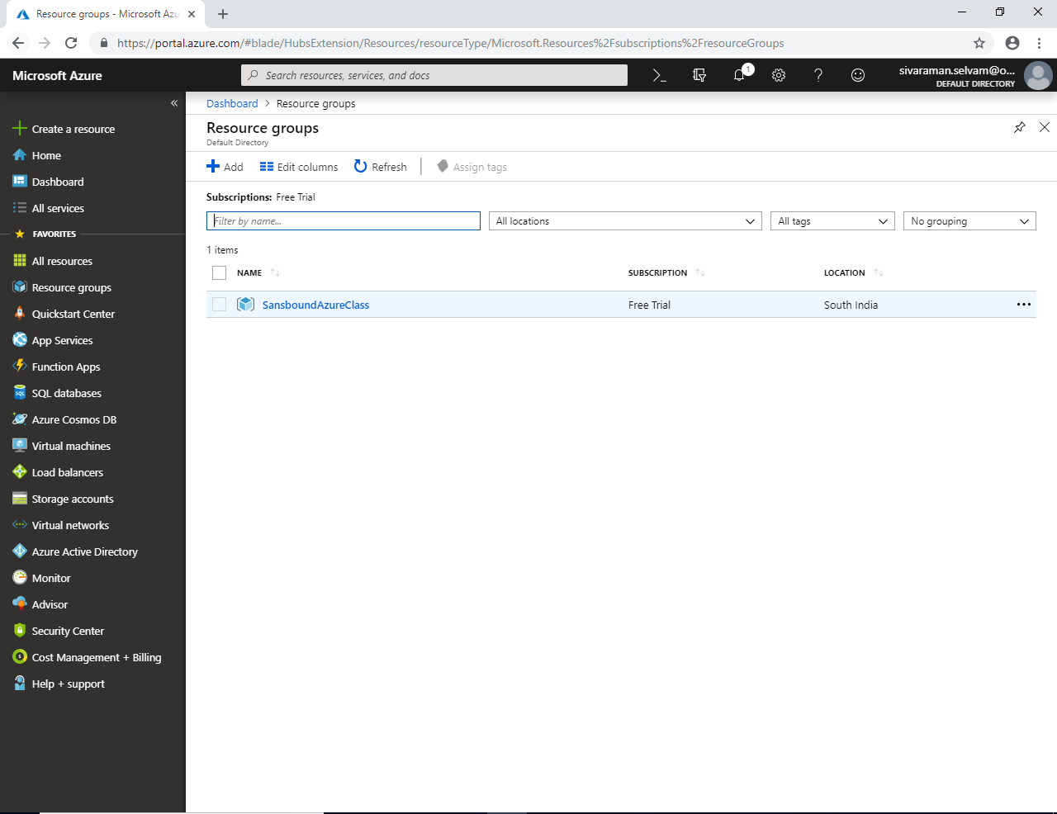

Click **“Virtual machines”** in left side panel.

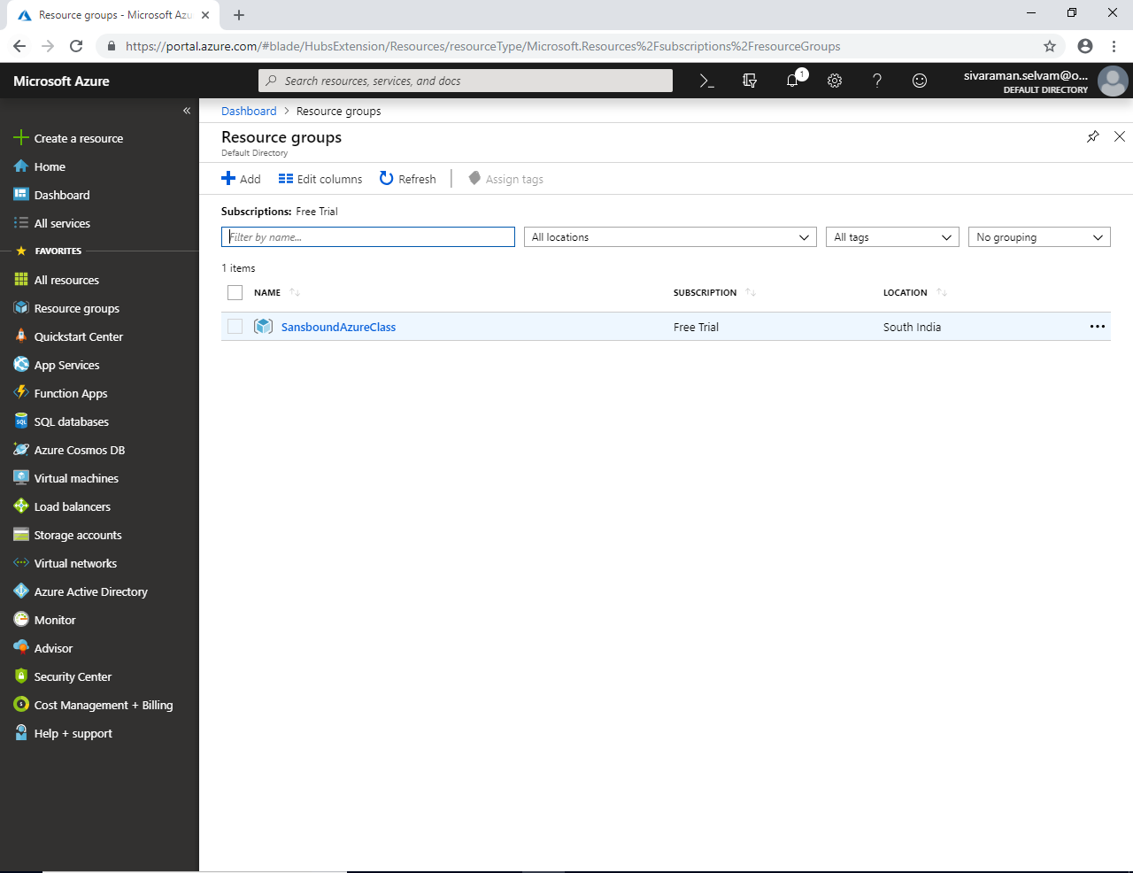

In **“Virtual machines”** click **“Add”**.

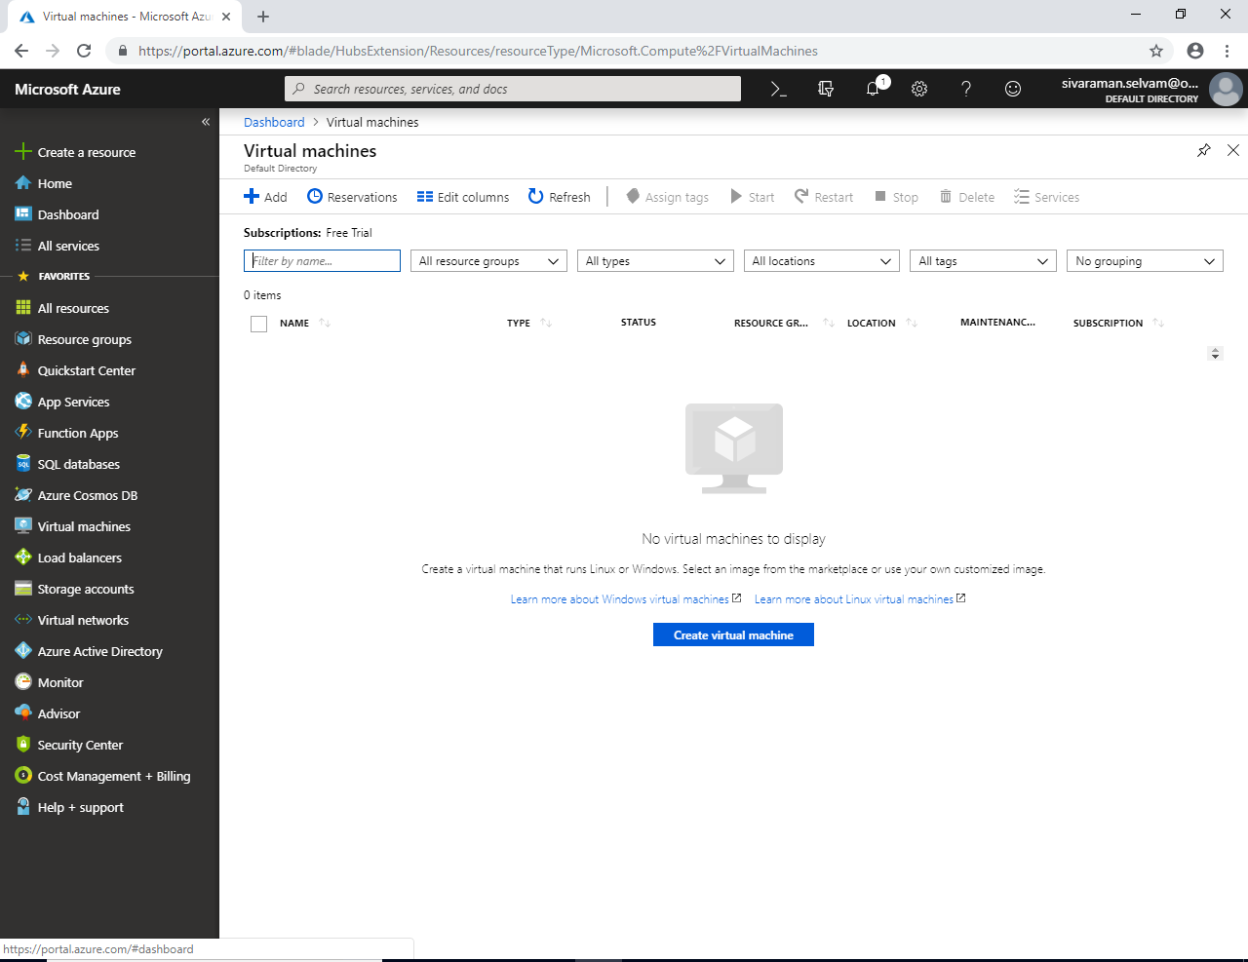

Select “Subscription”

Select “Resource Group” name as “SansboundAzureClass”.

Type “Virtual machine name” as “Win-WebSvrVM”.

Select “Region” as “South India”.

Select OS Image “Windows Server 2008 R2 SP1”.

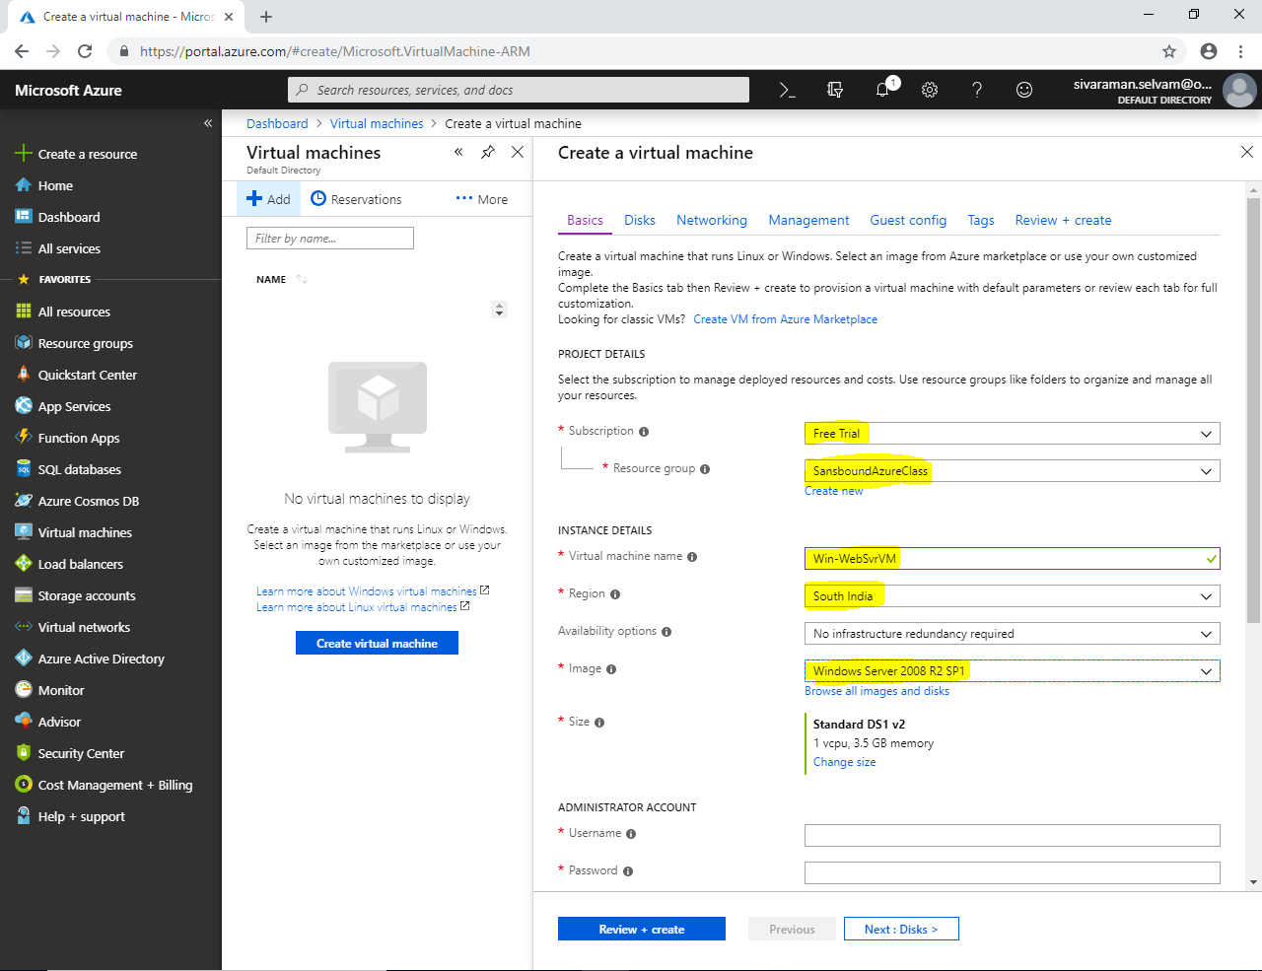

By default VM Size is as **“Standard DS1 v2”** and 1 vCPU and 3.5 GB memory. You should change the VM Size by click **“Change Size”**.

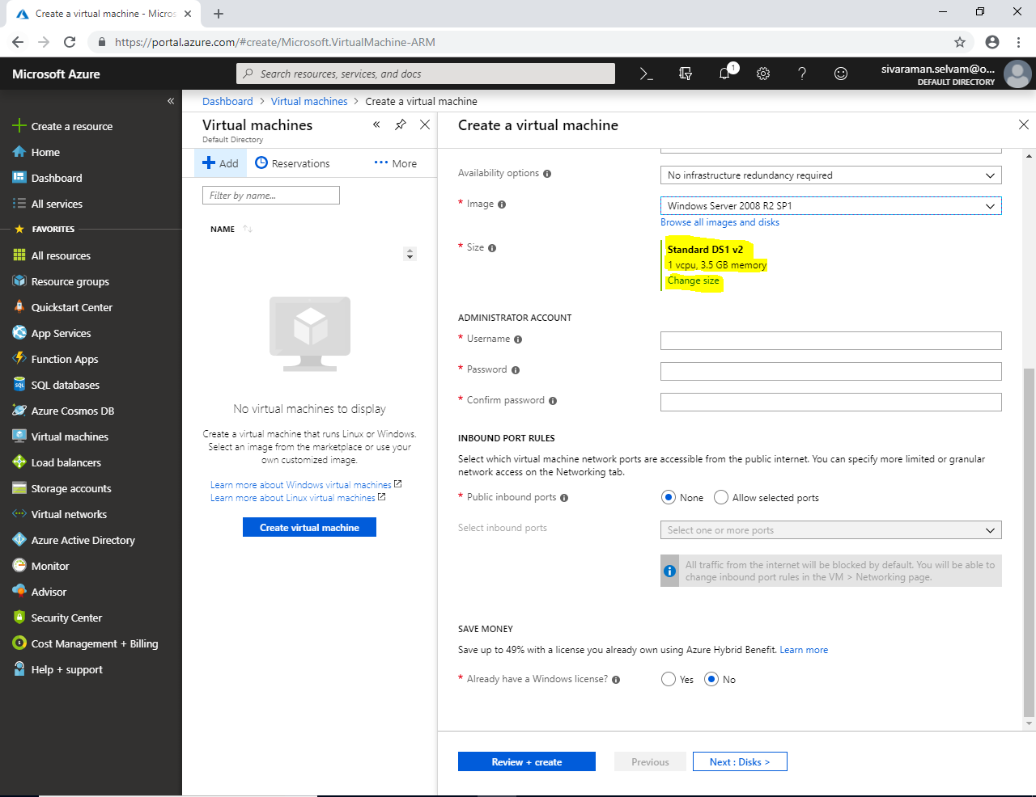

In **“VM Size”** click on **“B1s - Standard” and click “Select”.**

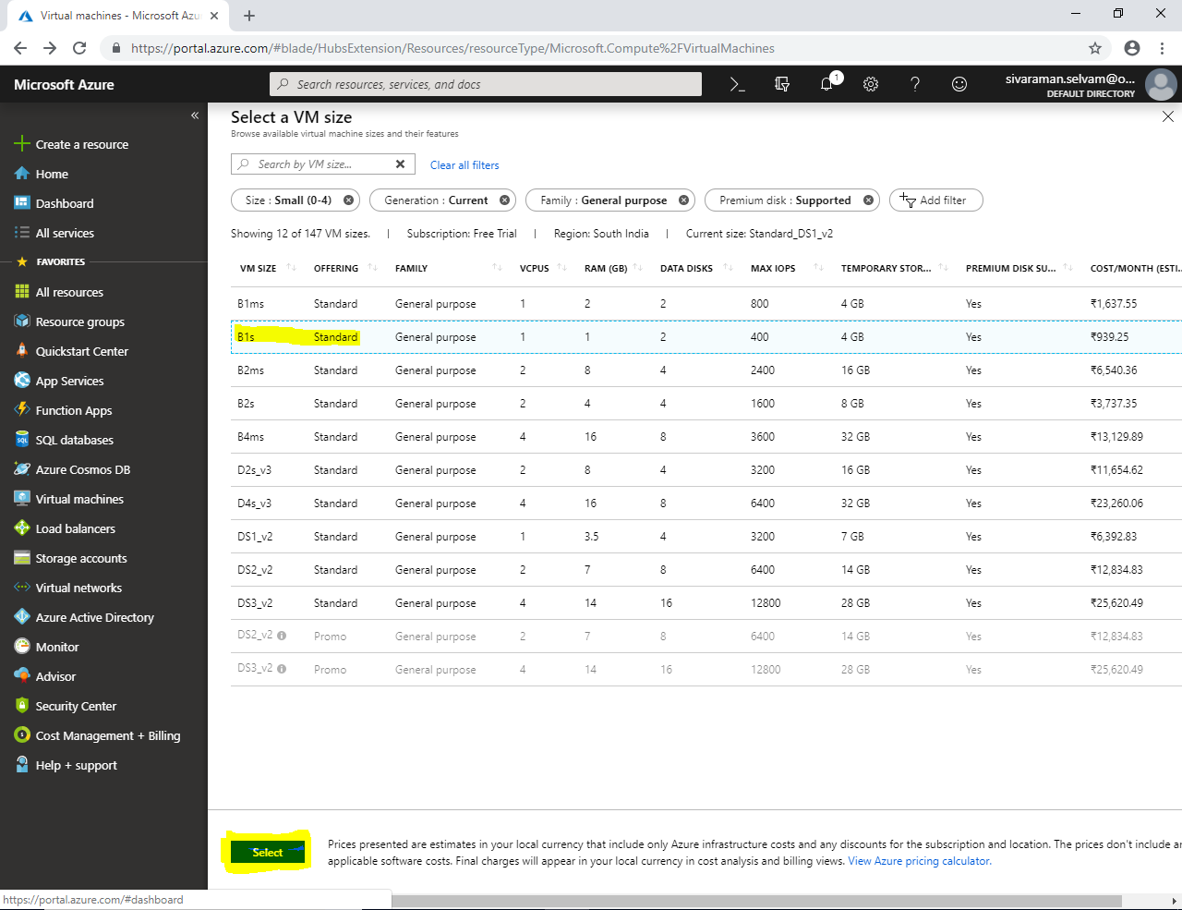

Ensure that **“Standard B1s”** VM Size is selected.

In **“Administrator Account”** type username as **“sansbound”** and type your own password.

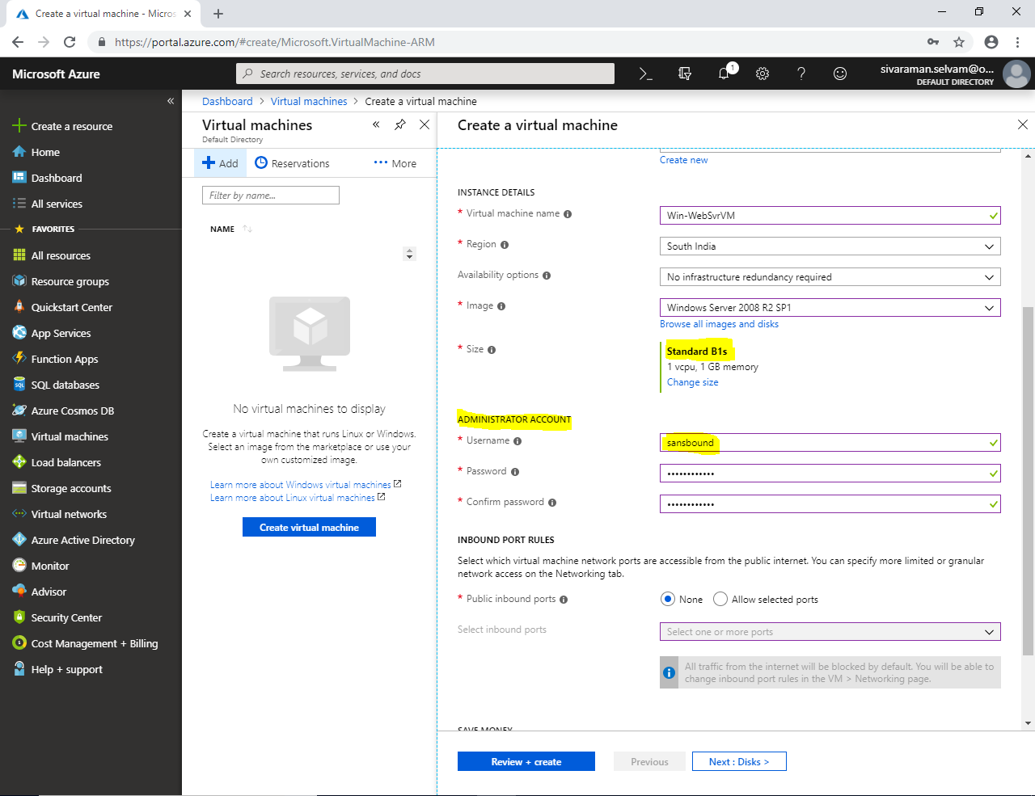

In **“Inbound Port Rules”**

In **“Public inbound ports”** click **“Allow selected ports”**.

In **“Select inbound ports”** select **“RDP (3389)”** from the drop down list.

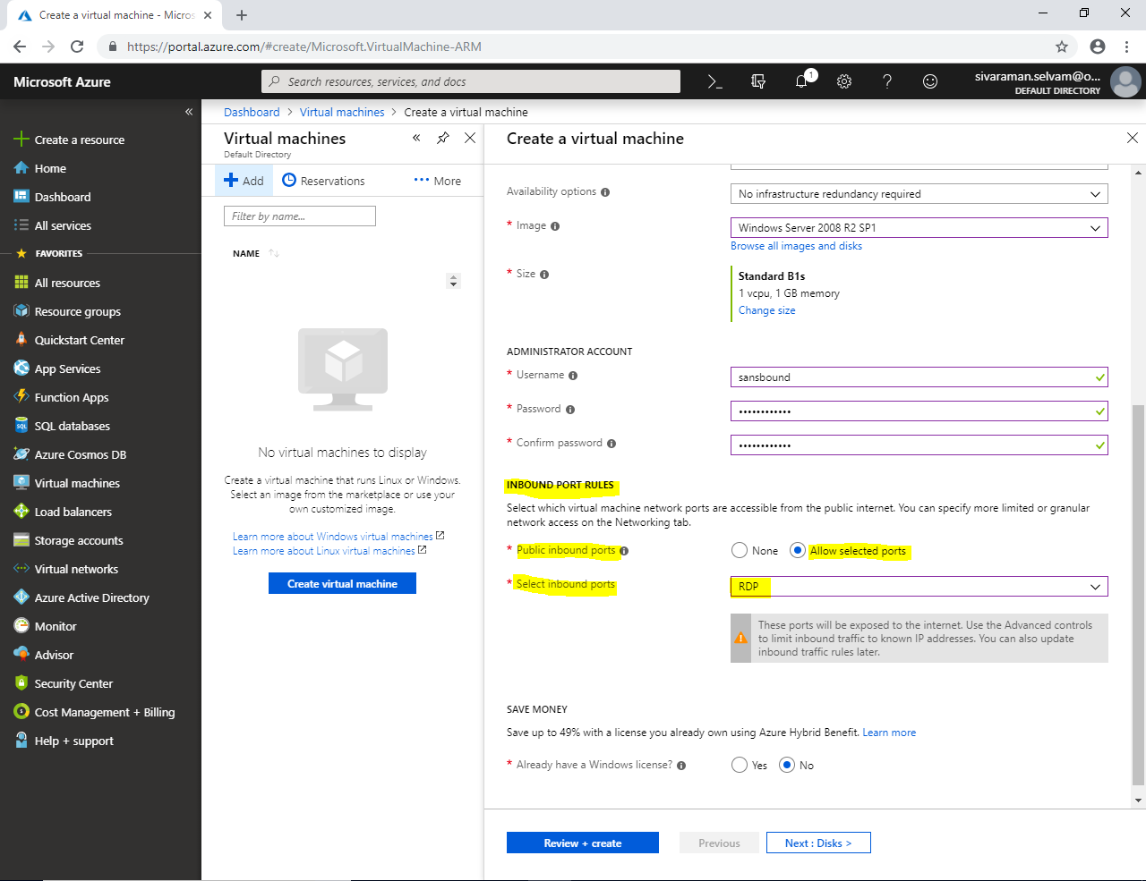

In “Save Money”,

Always have a Windows license as **“Yes”**.

Check the **“Confirmation”** box.

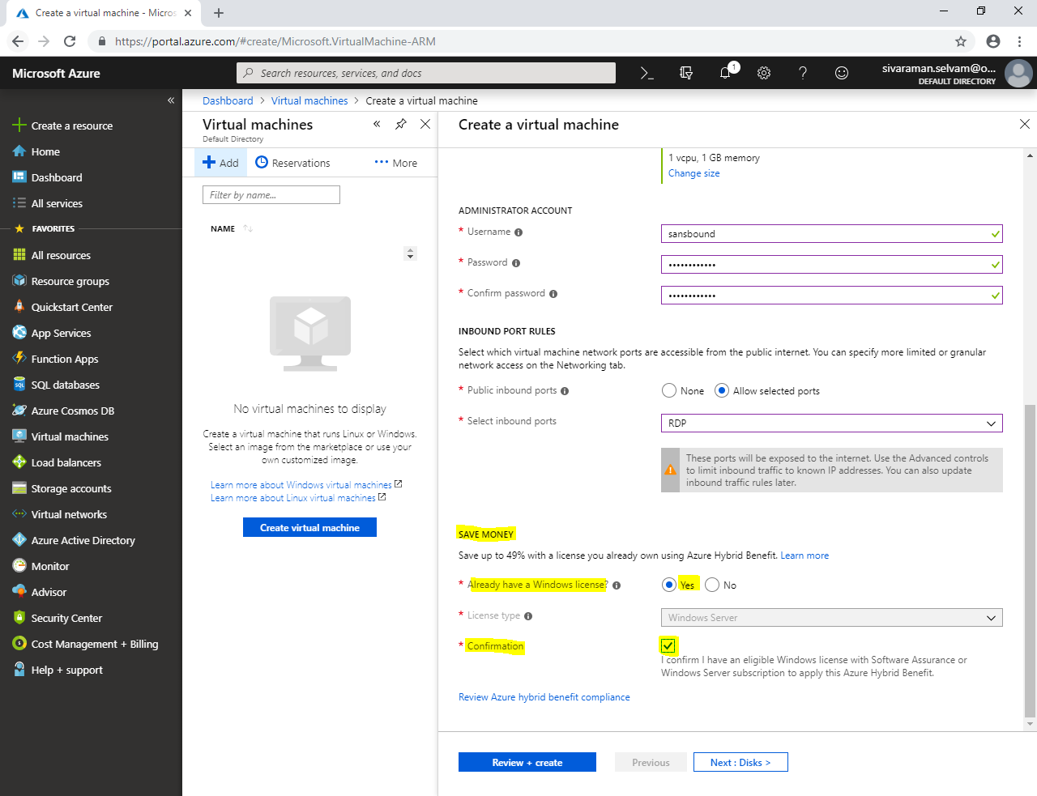

Then click **“Review + Create”**.

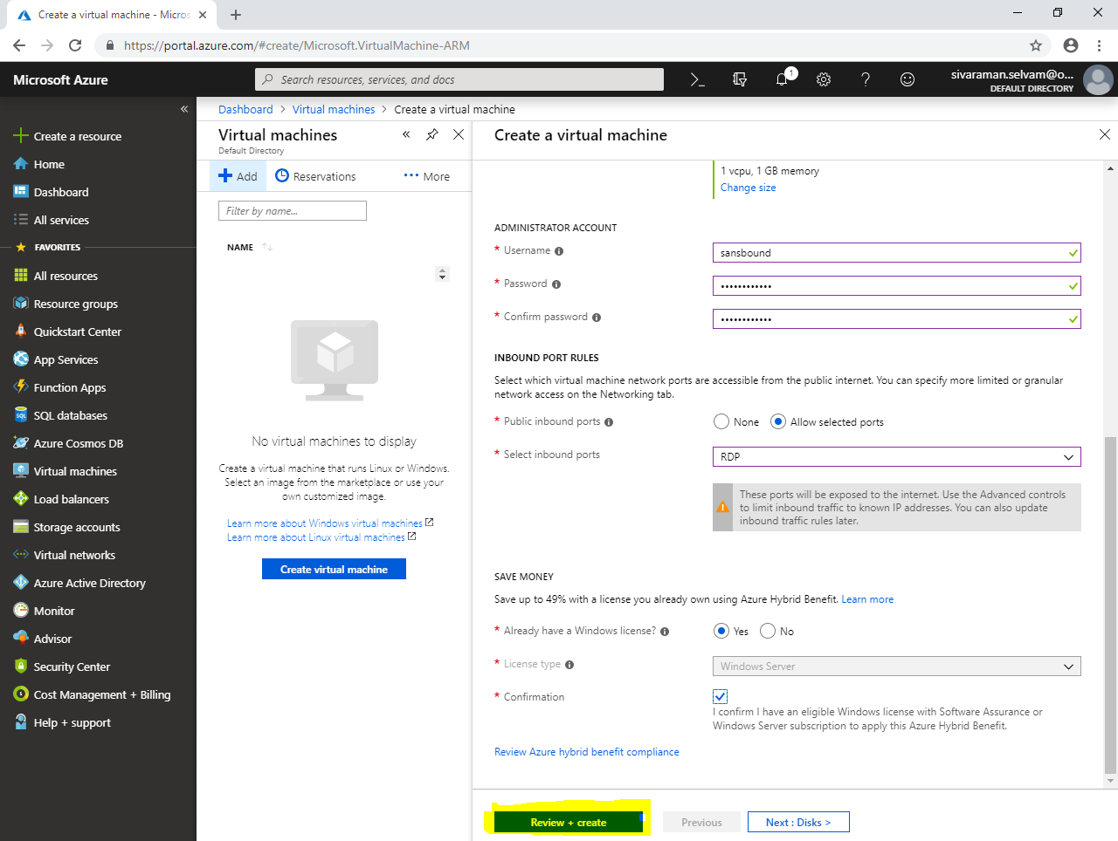

Click **“Create”** in bottom of the portal.

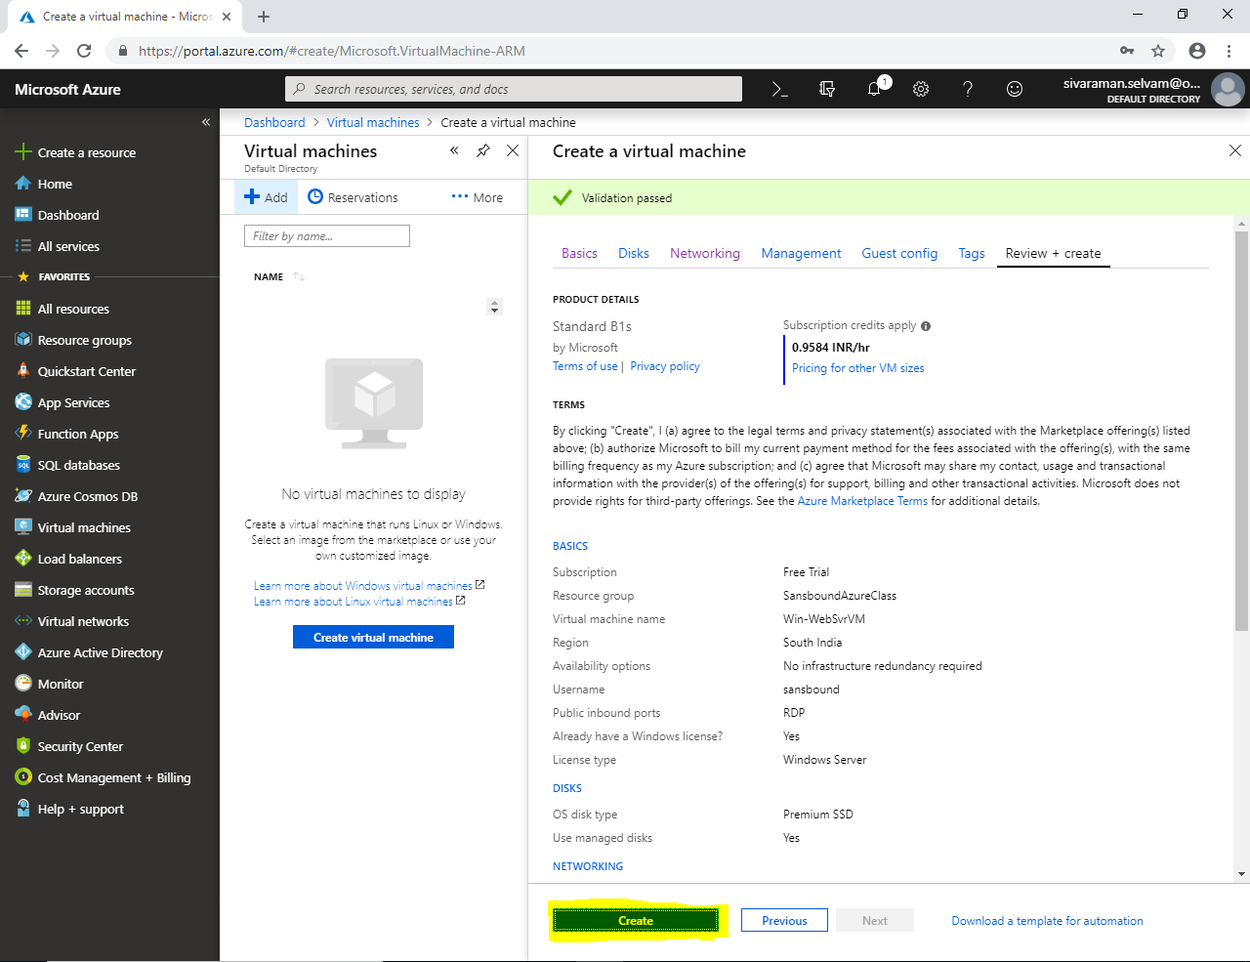

Click “Go to resource”.

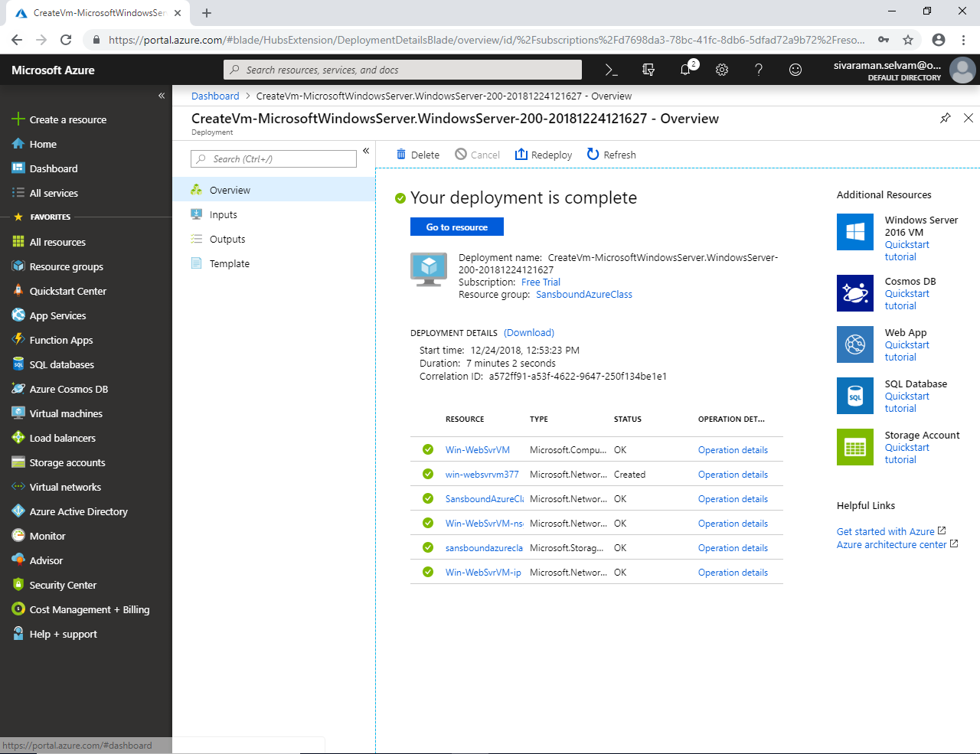

We have selected “Windows 2008 R2 Sp1”.

Kindly note the public IP address of the Windows VM which has been created for Web server.

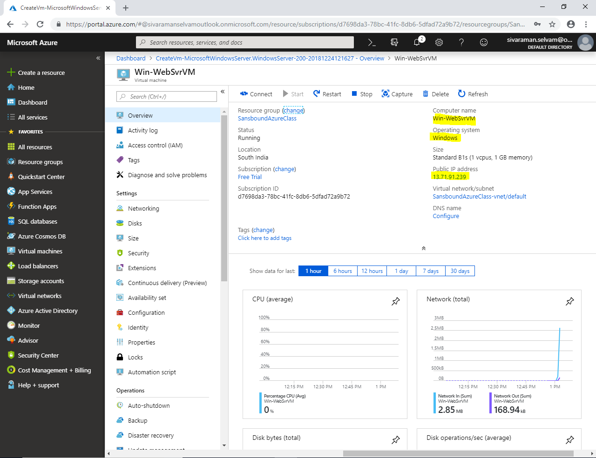

Type **“mstsc”** in run box and press “Enter”.

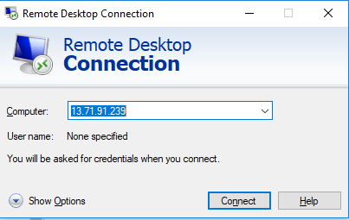

Click **”Connect”**

Type username as “sanbound”

Type password for the server which you have specified in the Azure portal while creating VM.

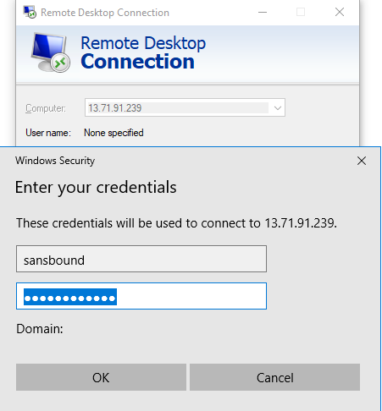

Click **”Ok”.**

**Click “Yes”.**

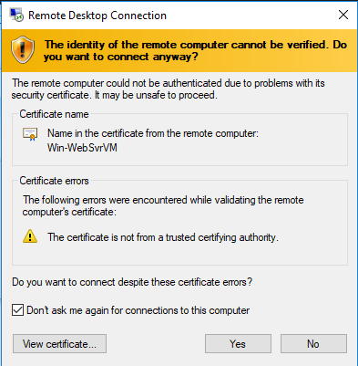

I have got **10.0.0.4** IP address for the **Windows 2008 R2 Sp1** server.

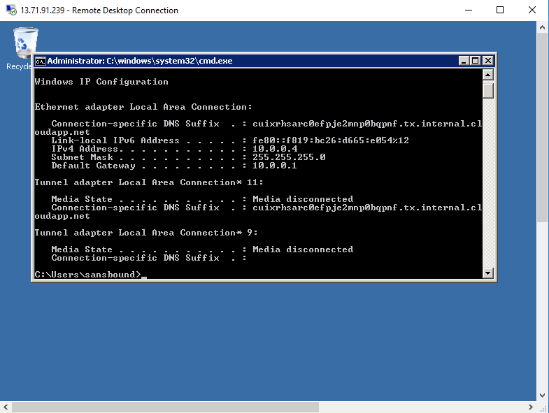

**Now I have required to install “IIS” in Windows 2008 R2 Sp1 Server to configure as “Web server”.**

**In “Windows 2008 R2 Server” click the high lighted icon of “Server Manager” in quick launch near start menu to launch it.**

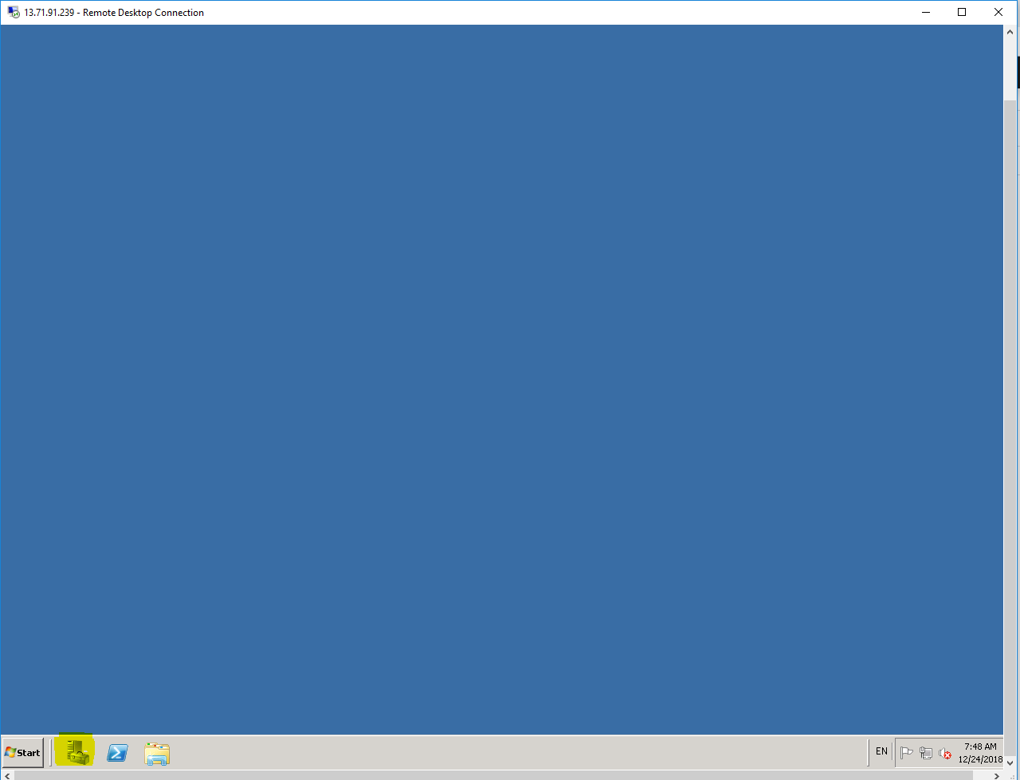

**In “Roles Summary” click “Add Roles”.**

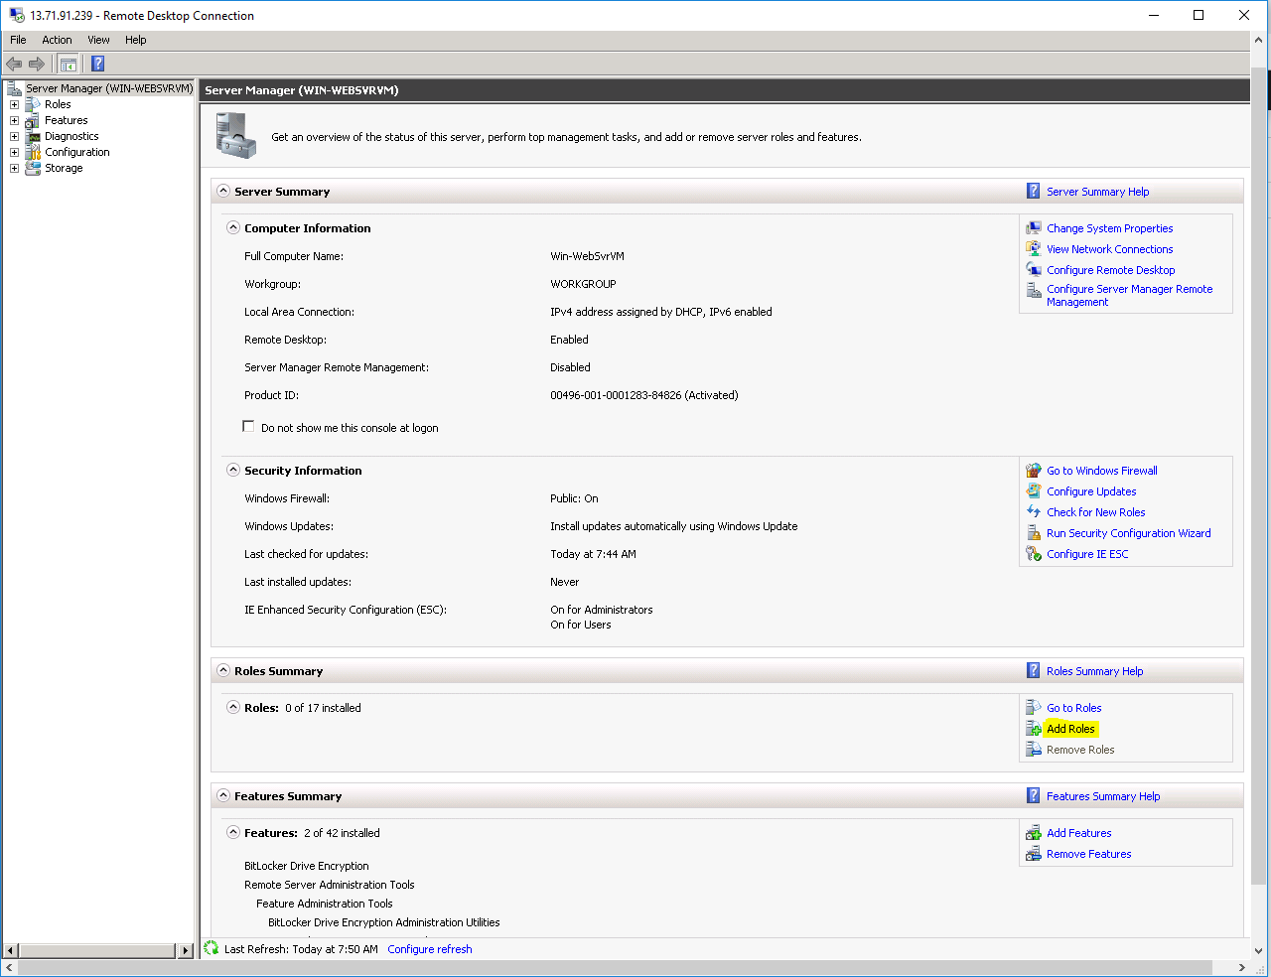

**Click ”Next”.**

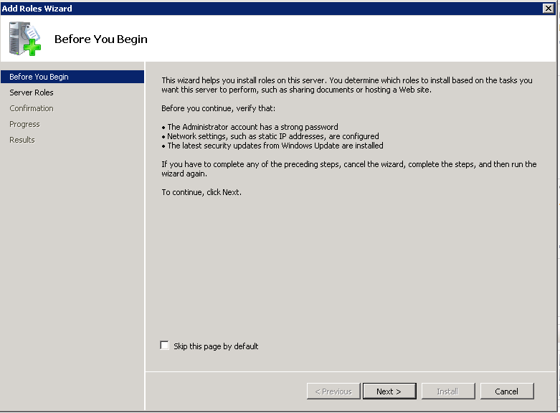

**In “Web server” you need to Check it.**

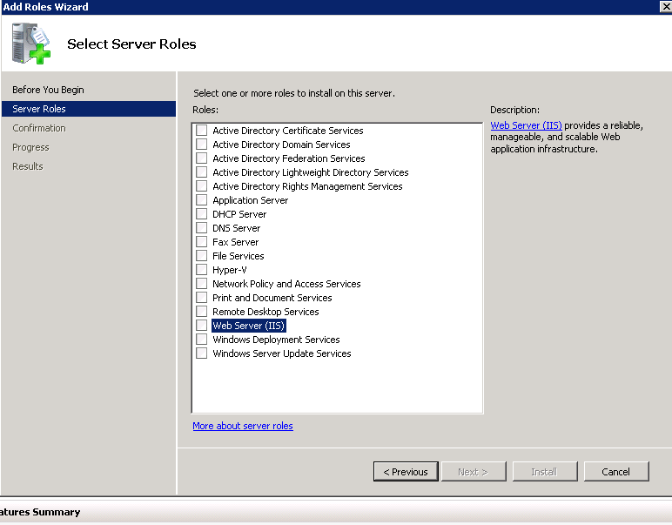

**Ensure that “Web Server (IIS)” is selected and click “Next”.**

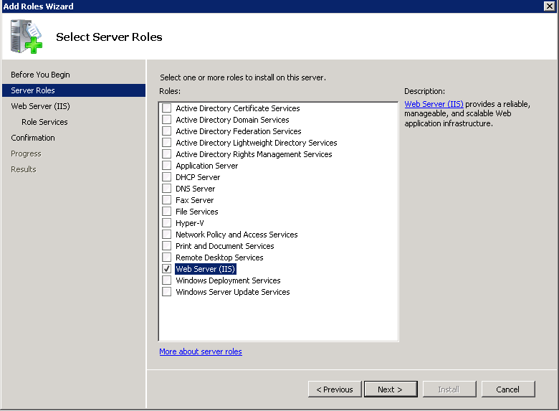

**Click “Next”.**

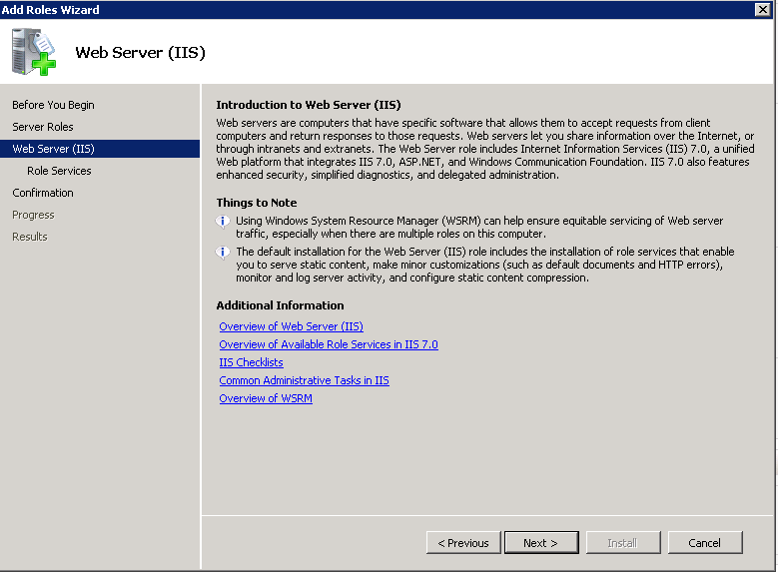

**In “Application Development”, need to check “ASP .Net”.**

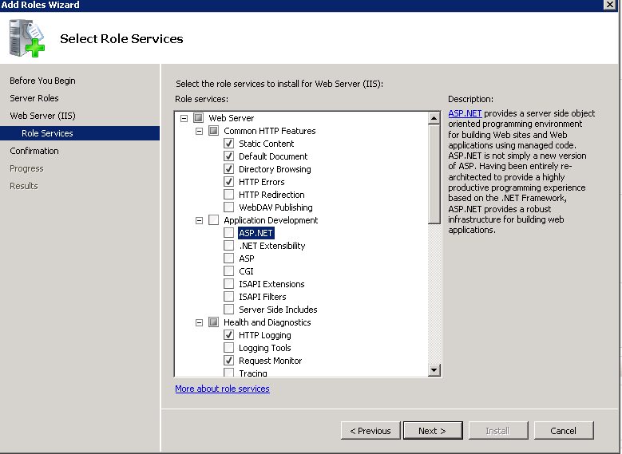

**Once you have checked the ASP.NET check box, you will get below window.**

**Click “Add required role services”.**

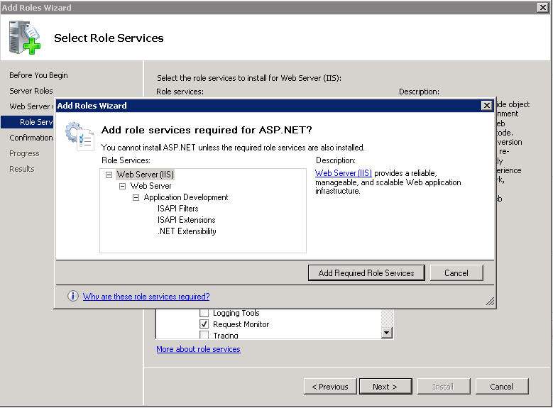

**Click “Next”.**

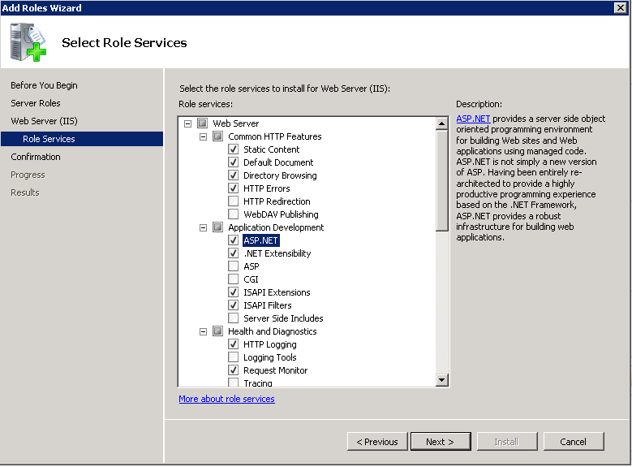

**Click “Install”.**

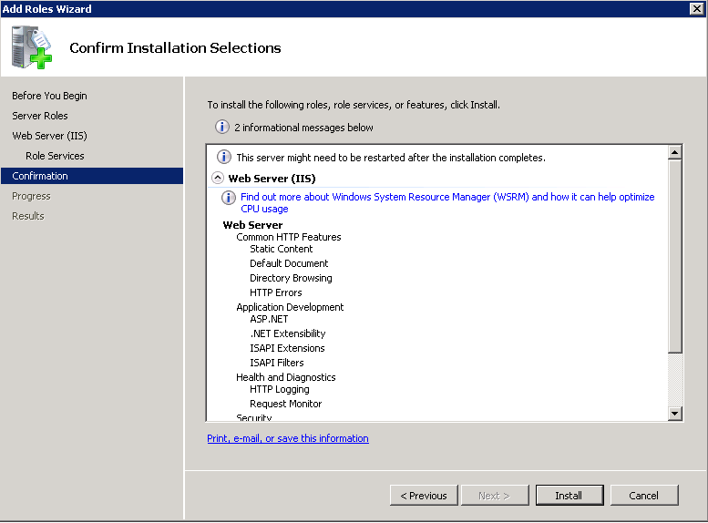

**Click “Close”.**

**You have successfully created web server in Windows.**

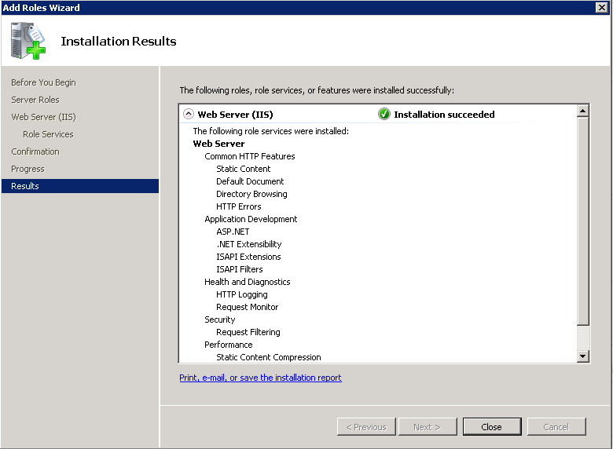

**In Server manager,**

**Click “Configure IE ESC”.**

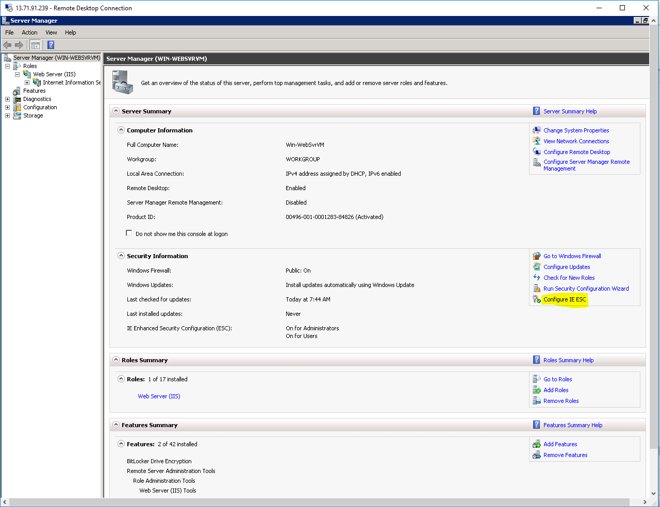

**In IE Enhanced Security Configuration,**

**Set “Off” for Administrators**

**Set “Off” for Users and click “Ok”.**

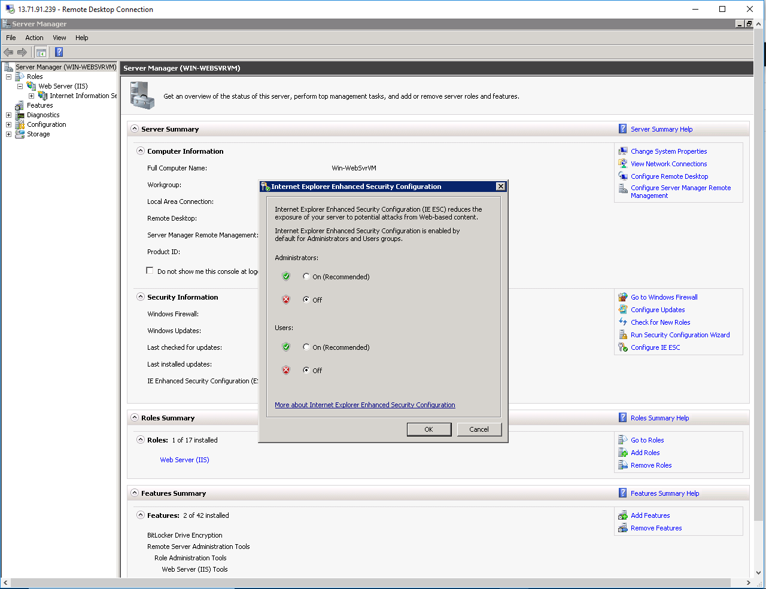

**In Windows Server 2008 R2, go to C:\inetpub\wwwroot**

**Open “Welcome.png”.**

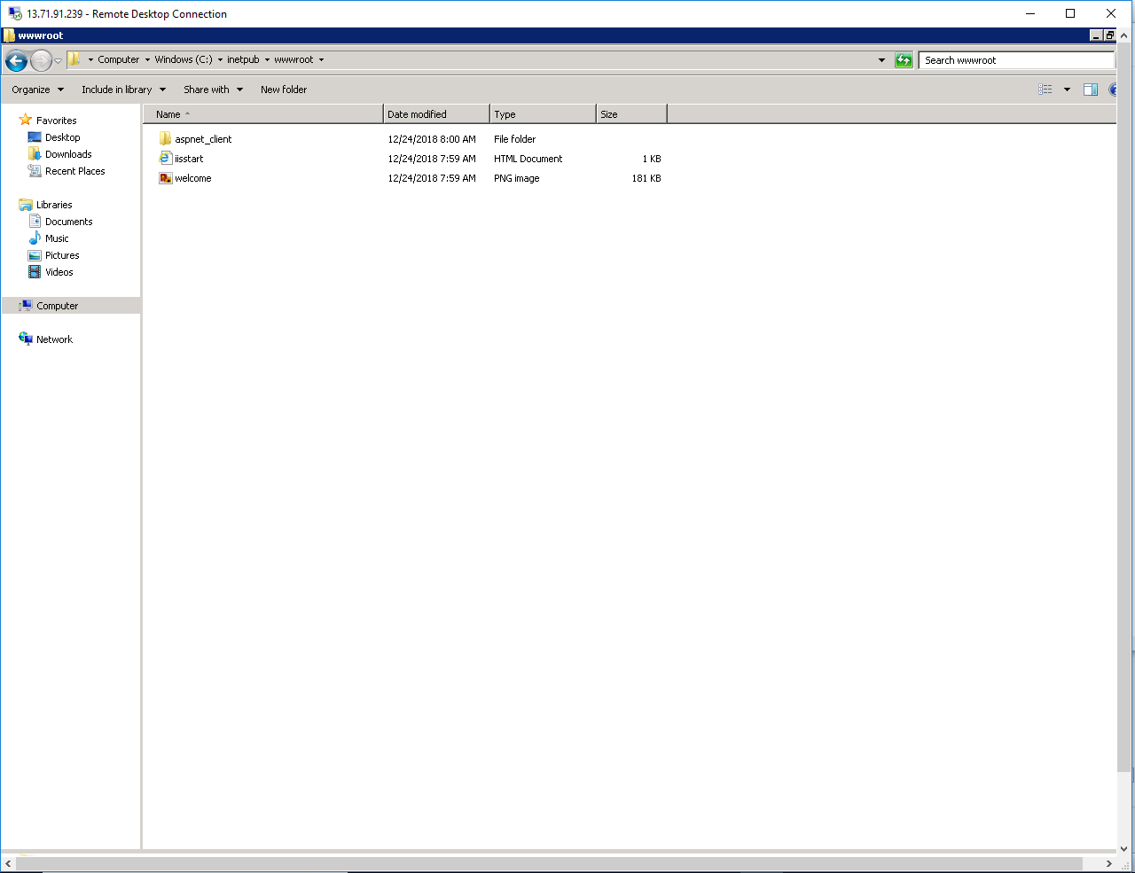

**Modify the Welcome.jpg as per your wish and save it.**

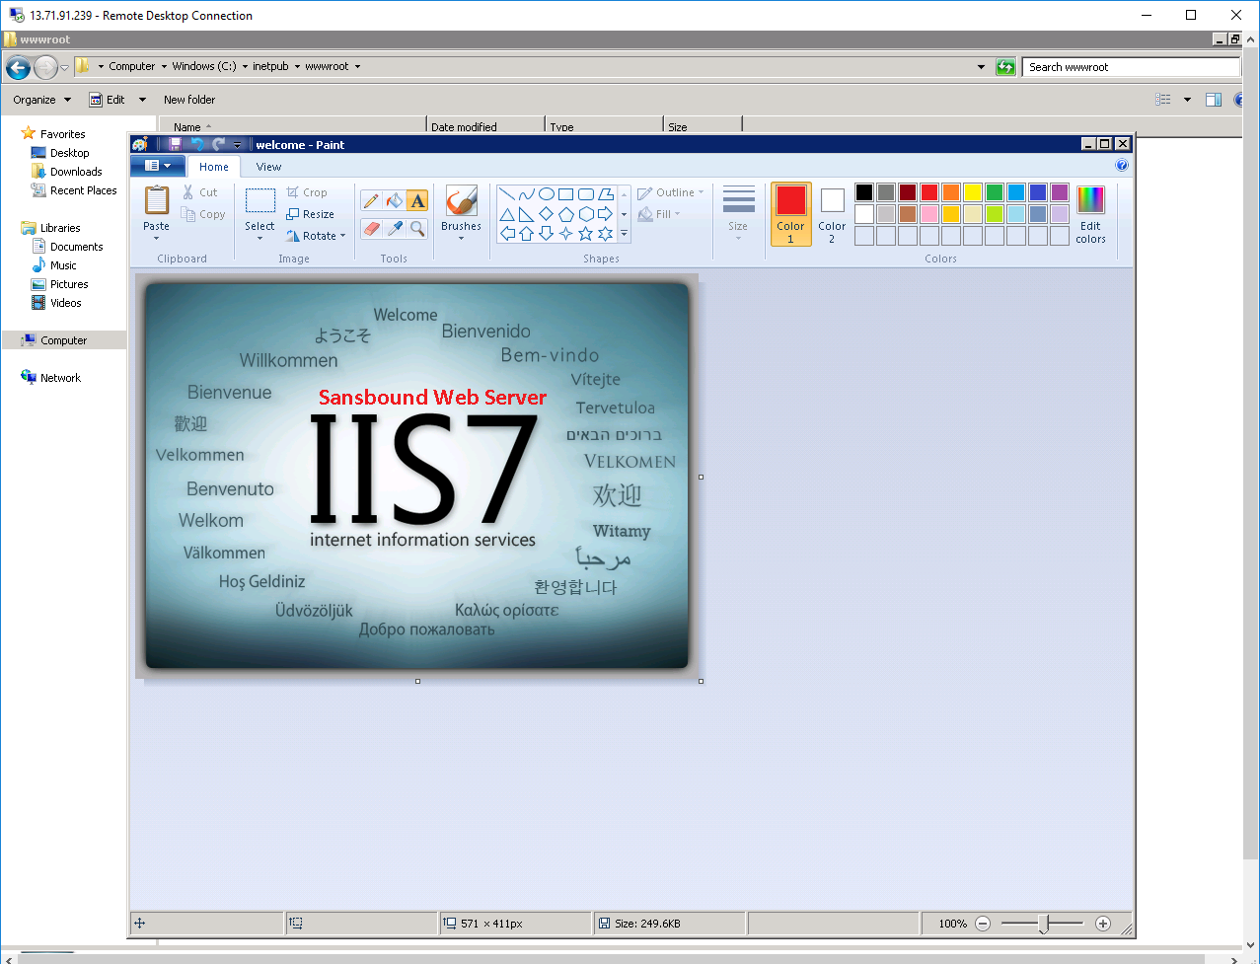

**In Windows 2008 R2 server, in Internet explorer type “localhost” and press “Enter” to get the web page.**

**Yes, we have successfully got the web page with in the Azure VM.**

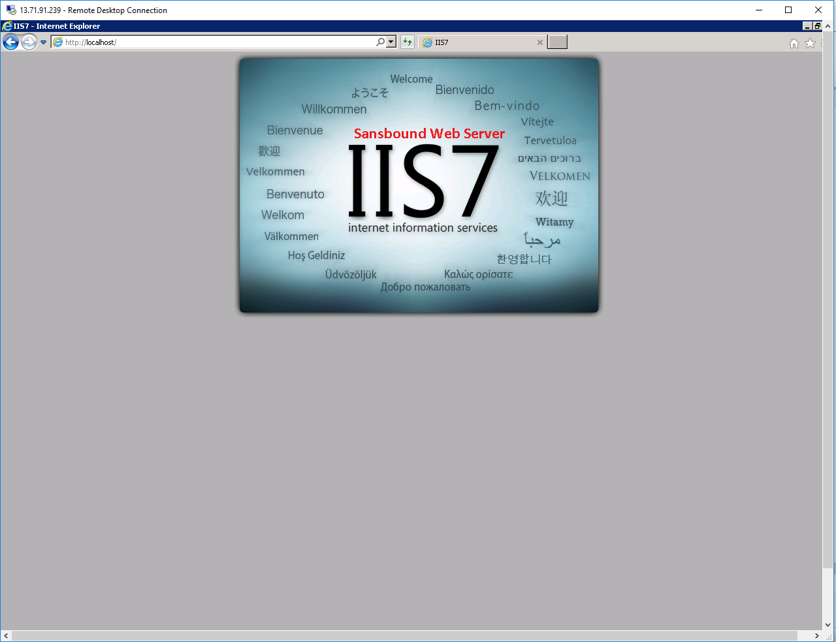

**Now we have required to access the Web server through public.**

**Kindly note the Public IP of the Windows Virtual Machine (Win 2008 R2) and try to connect from local machine.**

**But, you are not able to got the web page.**

**What could be the reason?**

**You have allowed only (RDP – 3389) Port only in inbound port rule to access selected ports from Public. That is the reason you are not able access the (HTTP – 80) Port through public. Hence you have required to permit HTTP (80).**

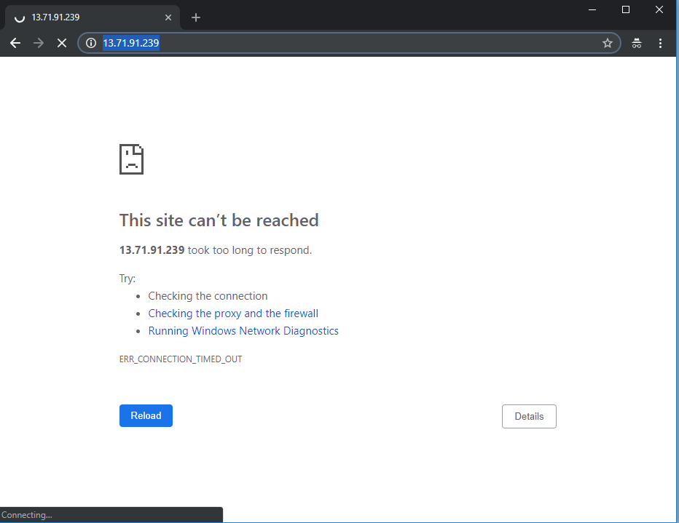

**Select the virtual machine,**

**Click “Networking”.**

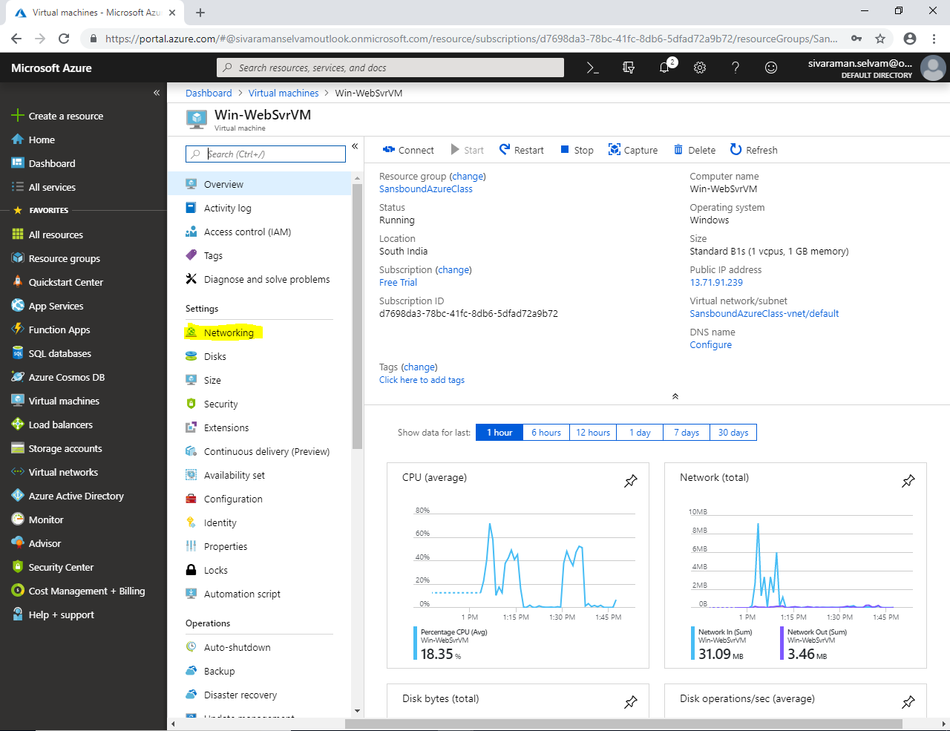

**In “Networking”**

**At “Inbound Port Rules” click “Add inbound port”.**

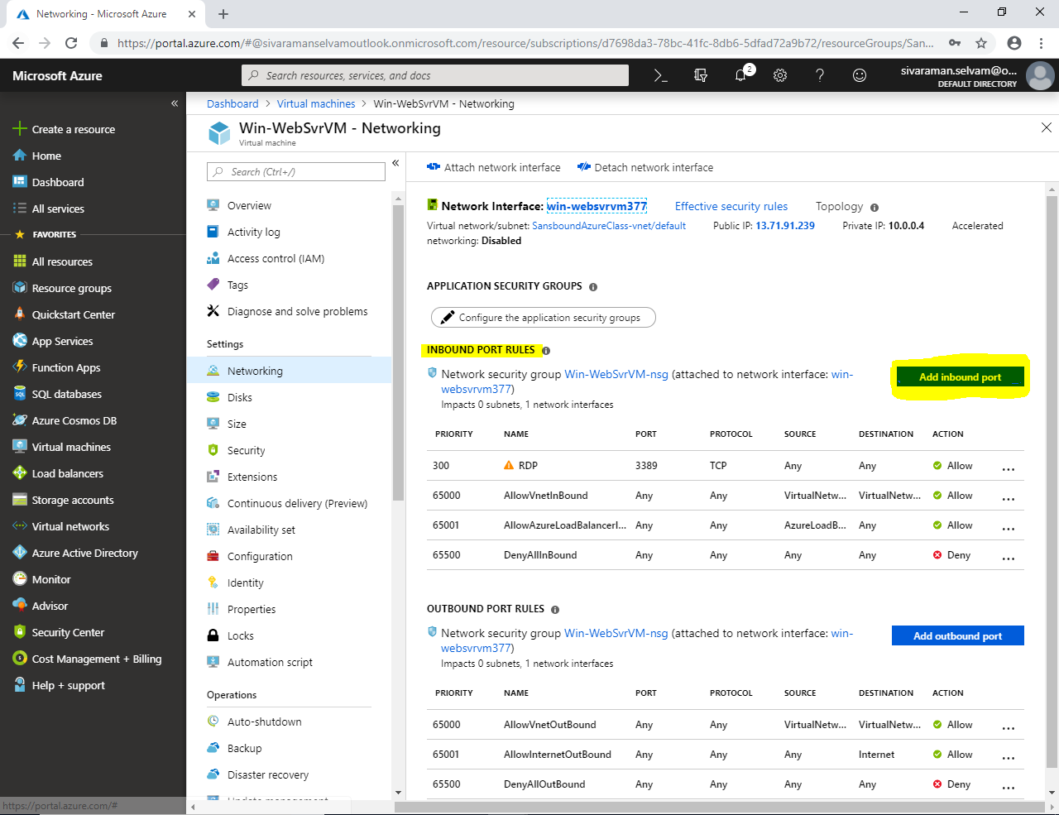

**Type “Destination port” range as “80”**

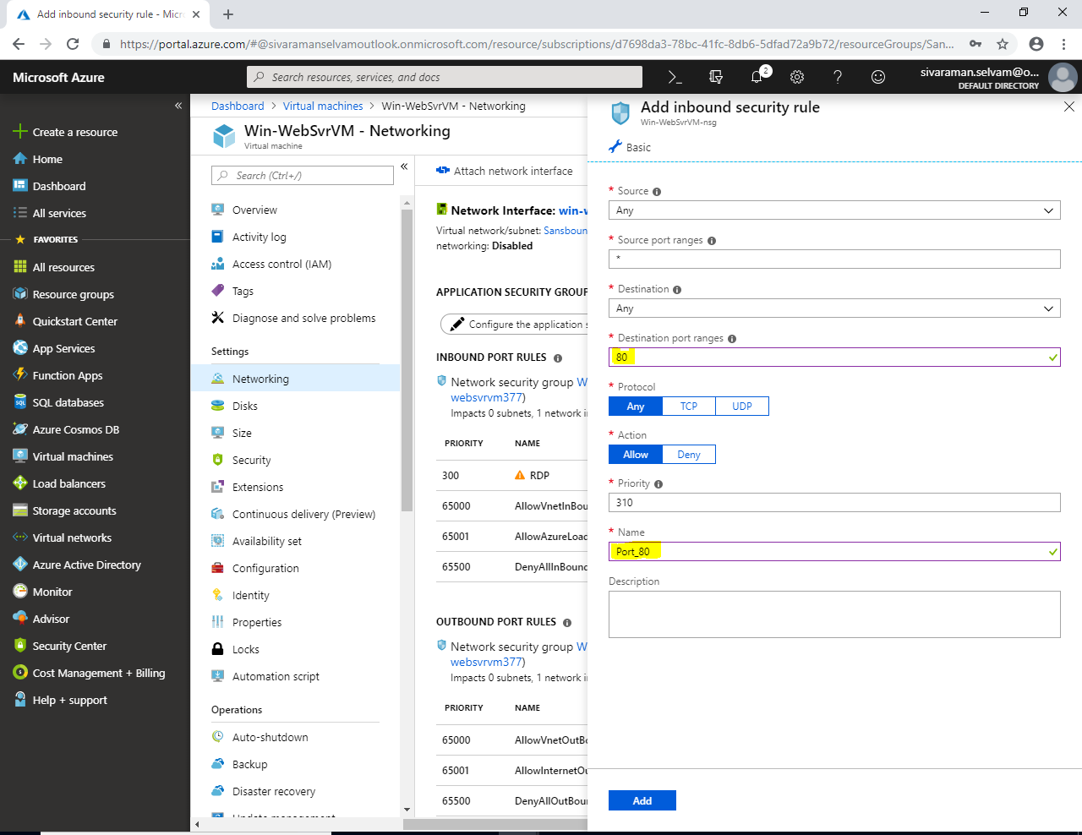

**Click “Add”.**

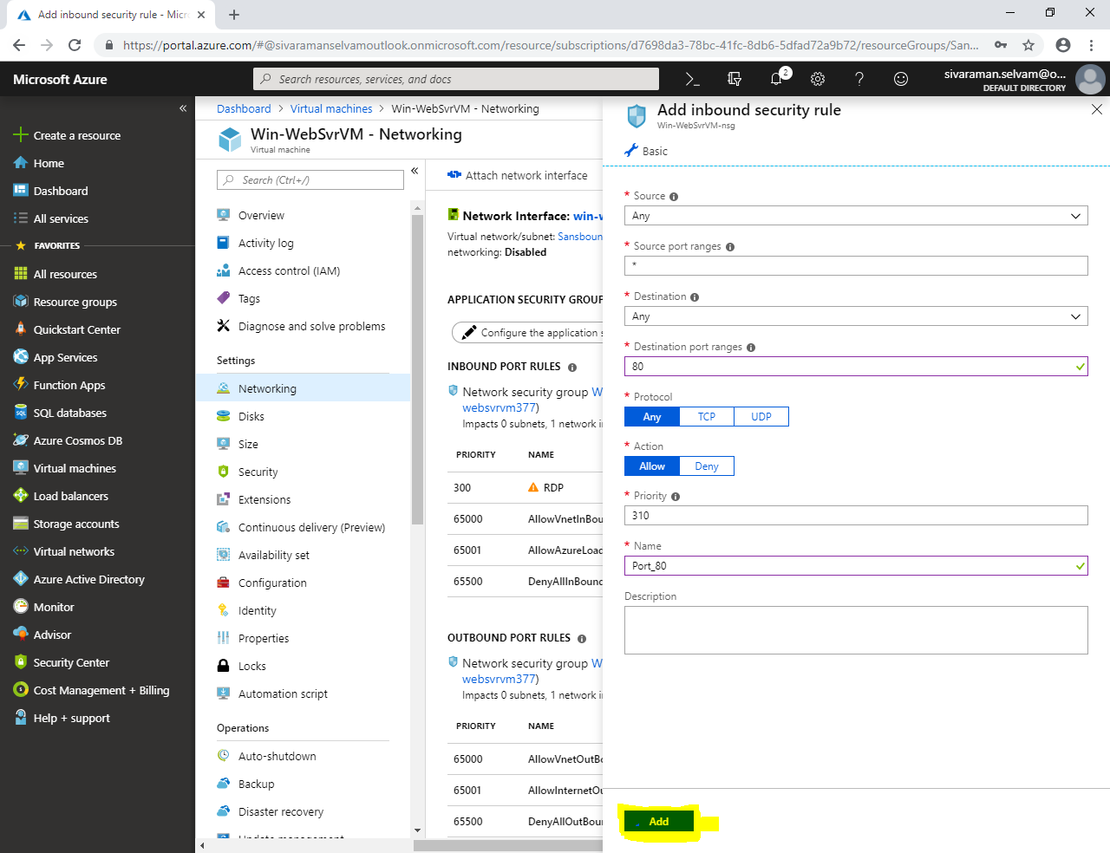

**Go to browser click “Refresh” to connect the webserver.**

**Now you have successfully connected to the Web server.**

